# Name: Owais Ali Khan, Roll no: 21K-3298 Section: F

AP LAB ASSIGNMENT:

Question 1: Write a program which takes the upper bound value from user and display the perfect squares between 1 and the upper bound.

Definition: Perfect squares are numbers whose square roots are whole numbers e.g:[1,4,9,16,25].

Sample Input:

Enter The Upper Bound: 133

Sample Output:

The Perfect Squares Are:

1, 4, 9, 16, 25, 36, 49, 64, 81, 100, 121

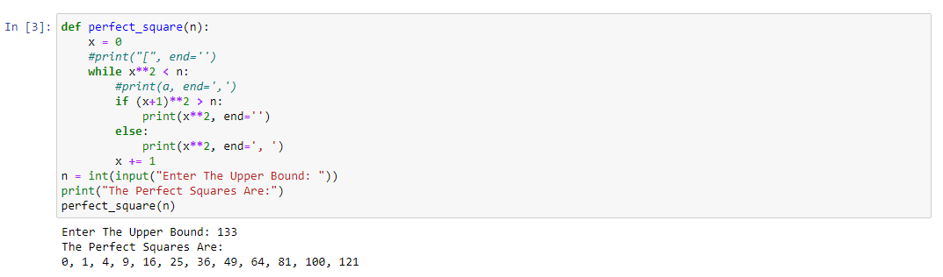

# Name: Owais Ali Khan, Roll no: 21K-3298 Section: F

Question 2: Write a python program that takes input from the user and pass this input into a function called fibonacci(n) this function prints the n terms of fibonacci series and return your roll number.

print your roll number in main function.

print your name and section first then print the fibonacci series.

Sample Input:

Enter Number Of values: 7

Sample Output:

My Name Is Taaha My section is B

Fibo Series:

[0 1 1 2 3 5 8]

My Roll Number Is: returned Value(e.g 210000)

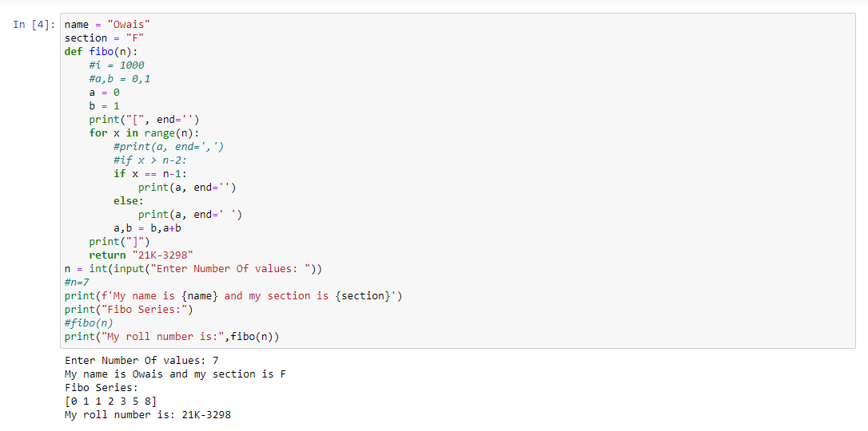

# Name: Owais Ali Khan, Roll no: 21K-3298 Section: F

Question 3: A ball is dropped from a tower of height h. It has initial velocity zero and accelerates downwards under gravity. The challenge is to write a program that asks the user to enter the height in meters of the tower and a time interval t in seconds, then prints on the screen the height of the ball above the ground at time t after it is dropped, ignoring air resistance. The steps involved are the following. First, we will use input statements to get the values of h and t from the user. Second, we will calculate how far the ball falls in the given time, using the standard kinematic formula:

s=1/2gt^2

where g = 9.81 ms-2 is the acceleration due to gravity. Third, we print the height above the ground at time t, which is equal to the total height of the tower minus this value. Write a python function to calculate the height of a ball after the t seconds.

Hint: Height(h,t) ► return h-s

Instruction: Take input height as your roll number E.g. if your roll number is 19K1328 then take 1328 as height.

Sample Input:

Enter the height of the tower: 1328

Enter the time interval: 9

Sample Output

The height of the ball is 930.6949 meters

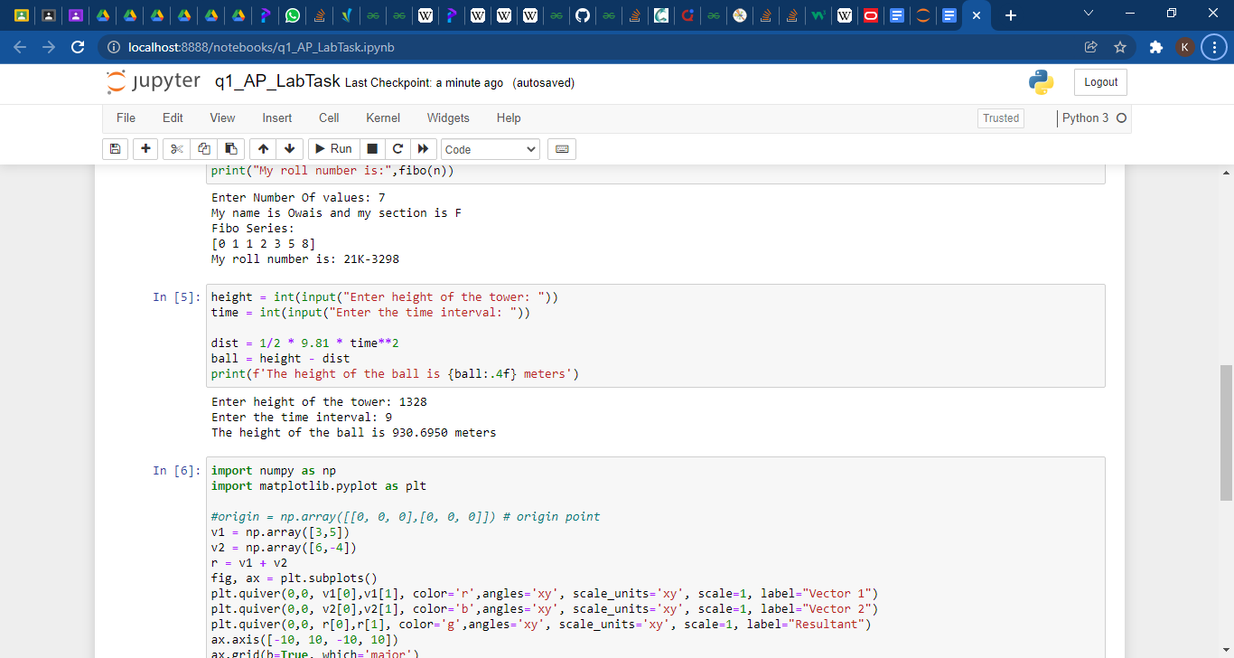

# Name: Owais Ali Khan, Roll no: 21K-3298 Section: F

Question 4: Plot two vectors and their resultant vector using matplotlib library functions in Python.

